**GROUP 9**

**Exp No.10(A)**

**OBJECTIVE: LED blinking using Rashberry Pi 3 Model B**

**BLOCK DIAGRAM:**

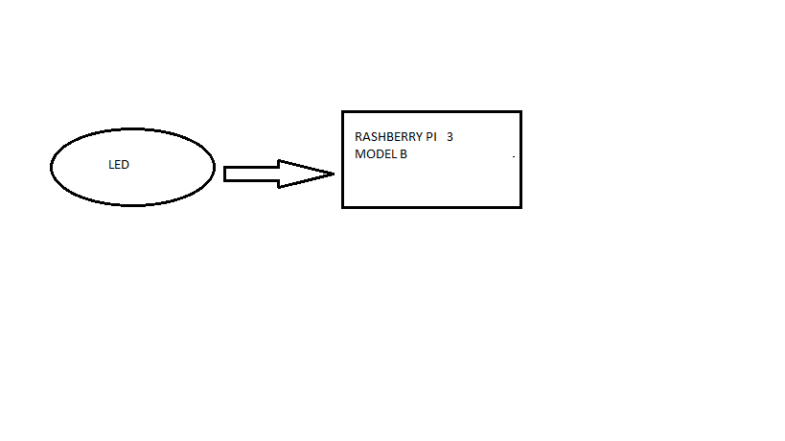

**Fig 1**

**EXPLANATION:**

Here we firstly connect resistor with led in a bread-board.Then led to pin 11 (GPIO 17) of Rashberry Pie 3 Model B board and code a program in Rashberry Pie IDE to get the desired output in the serial-monitor.

**APPARATUS:**

* LED
* Resistor
* Jumper Wires
* Rashberry Pie 3 Model B board
* PC(with RPI IDE )

**CODE:**

import time

import RPi.GPIO as GPIO

from RPi import GPIO

GPIO.setmode(GPIO.BCM)

GPIO.setup(17,GPIO.OUT)

try:

while True:

GPIO.output(17,GPIO.HIGH)

time.sleep(1)

print("On")

GPIO.output(17,GPIO.LOW)

time.sleep(1)

print("Off")

except KeyboardInterrupt:

pass

finally:

GPIO.cleanup()

**Exp No.10(B)**

**OBJECTIVE: Control the Brightness of LED using PWM on Raspberry Pi**

**BLOCK DIAGRAM:**

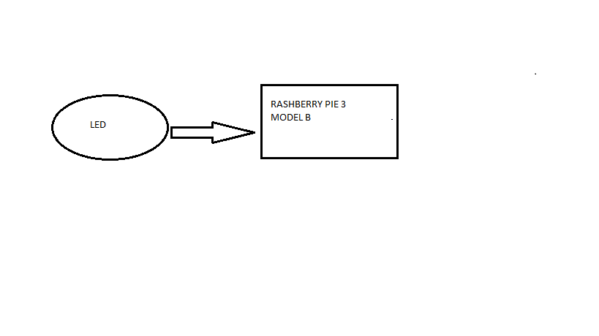

**Fig 2**

**EXPLANATION:**

Here we firstly connect resistor with led in a bread-board.Then led to PWM pin 12 (GPIO 18) of Rashberry Pie 3 Model B board and code a program in Rashberry Pie IDE to get the desired output in the serial-monitor.

**APPARATUS:**

* LED
* Resistor
* Jumper Wires
* Rashberry Pie 3 Model B board
* PC(with RPI IDE )
* Micro USB cable

**CODE:**

import RPi.GPIO as GPIO

from time import sleep

ledpin = 18 # PWM pin connected to LED

GPIO.setwarnings(False)

GPIO.setmode(GPIO.BCM) #set pin numbering system

GPIO.setup(ledpin,GPIO.OUT)

pi_pwm = GPIO.PWM(ledpin,50) #create PWM instance with frequency of 50 Hertz

pi_pwm.start(0) #start PWM of required Duty Cycle

while True:

for duty in range(100):

pi_pwm.ChangeDutyCycle(duty) #provide duty cycle in the range 0-100

sleep(0.04)

sleep(1)

for duty in range(100):

pi_pwm.ChangeDutyCycle(100-duty)

sleep(0.04)

sleep(1)